Copyright for test papers and marking guides remains with West Australian Test Papers.
Test papers may only be reproduced within the purchasing school according to the advertised Conditions of Sale.
Test papers should be withdrawn after use and stored securely in the school until 30 November 2018.



SEMESTER TWO

MATHEMATICS
METHODS
UNITS 1 & 2

2018

SOLUTIONS

Calculator−free Solutions

1. (a) 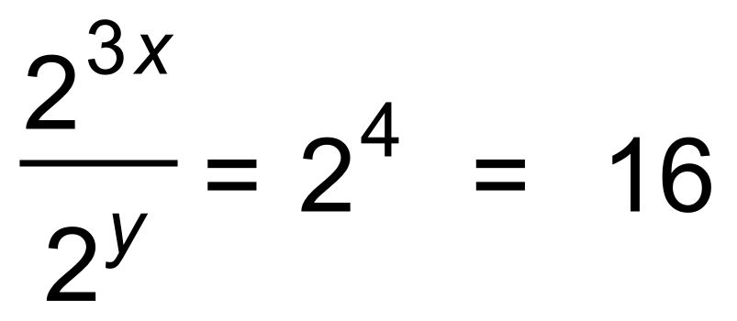
(b) 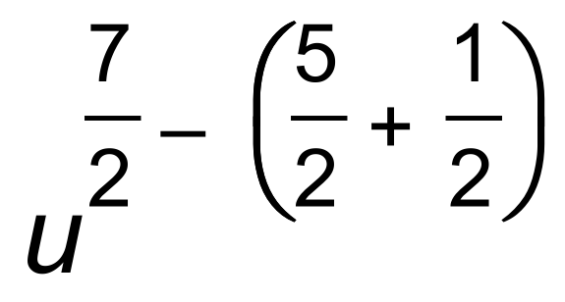
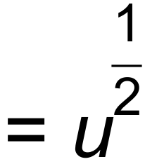 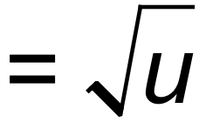 [4]

2.
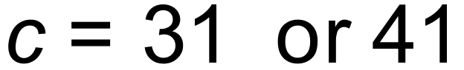 [4]

3. (a) 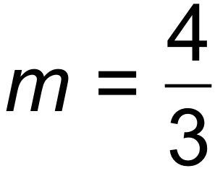
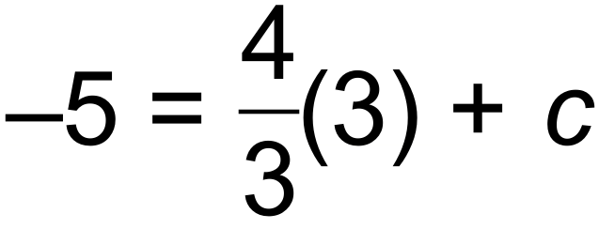
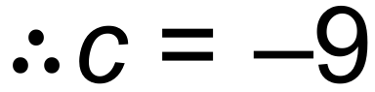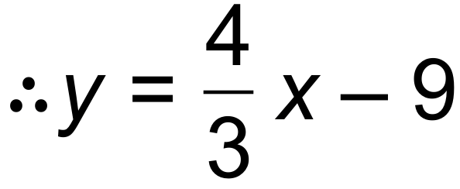
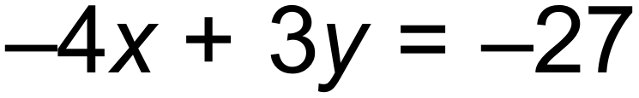
(b) 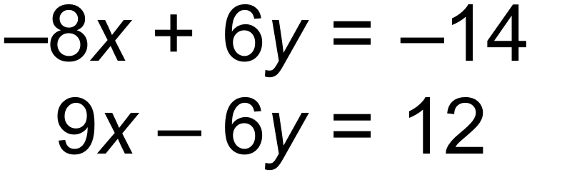
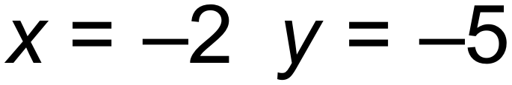
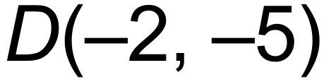
(c) 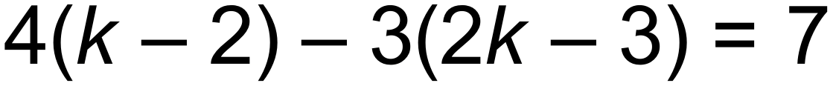
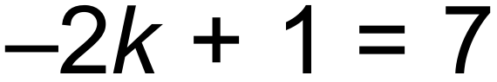
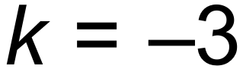 [7]

4. 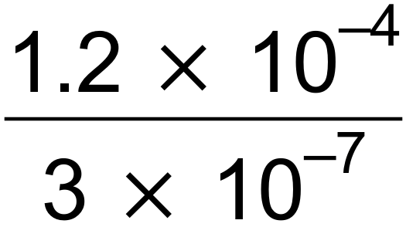 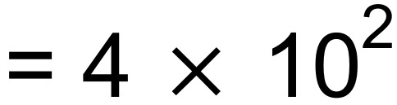 = 400 [2]

5. (a) 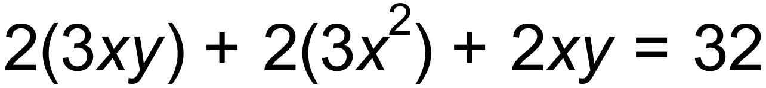
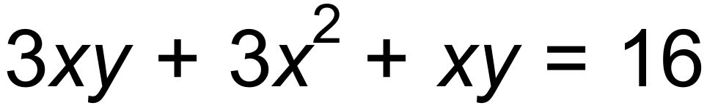
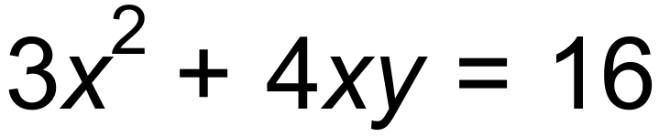
(b) 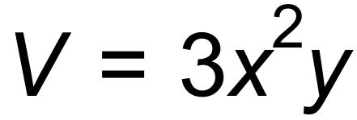 and 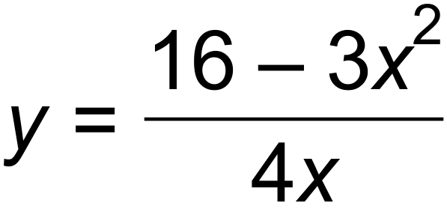
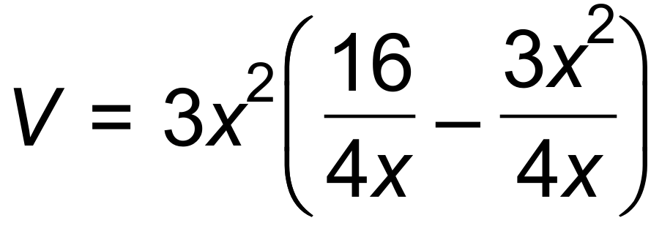
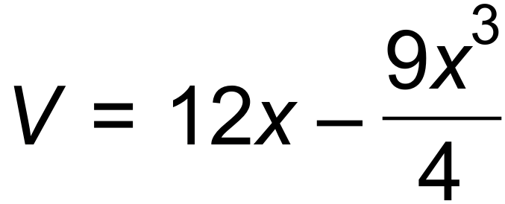
(c) 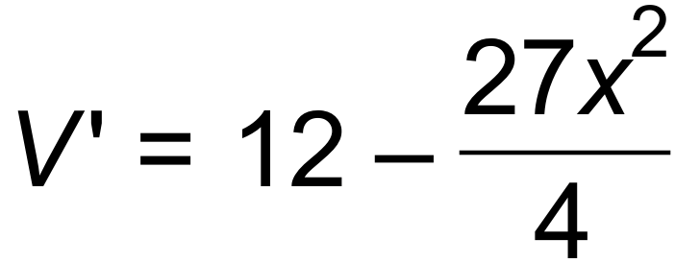
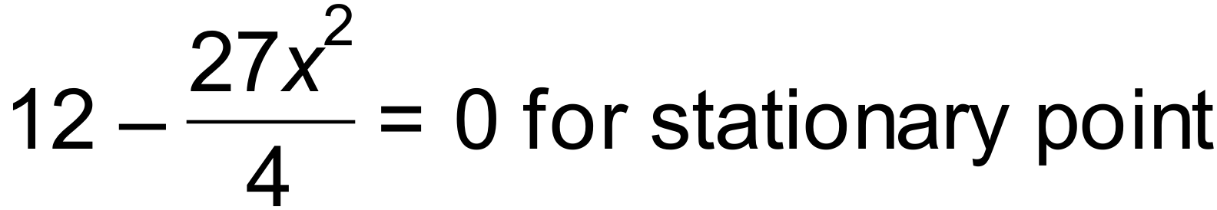
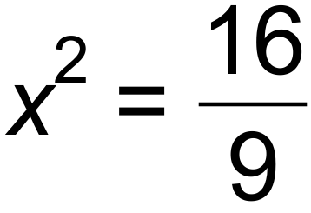
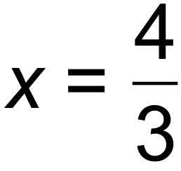 (discard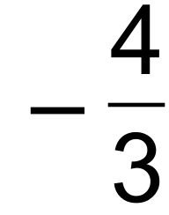 )

(d)
V(x) | ↑ |  | ↓
V’(x) | + | 0 | 
V has a maximum value [9]

6. (a) T_{n+1} = T_{n} +10 T₁ = 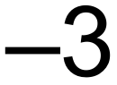
(b) T₂ = 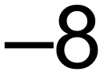
T₃ = −32 [4]

7. (a) 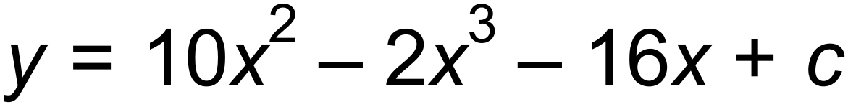
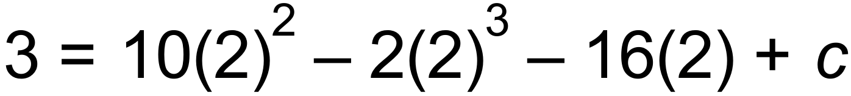
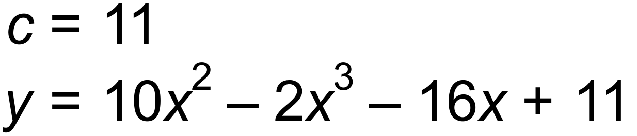
(b) Gradient of xaxis = 0
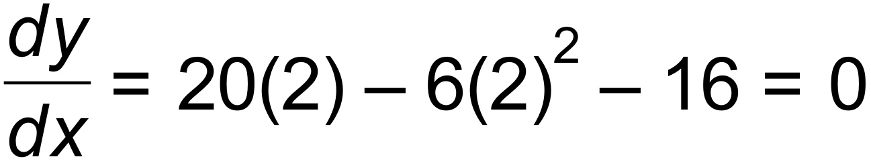
 Tangent is horizontal and parallel to the x$-$axis. [5]

8. (a) Vertical translation 12 units down
Horizontal dilation by factor .
(b) 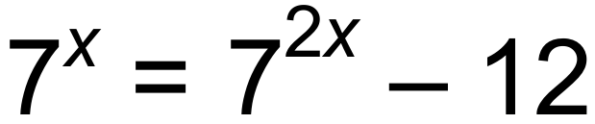
Let 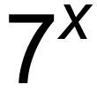 be k. 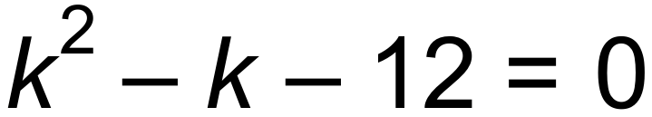
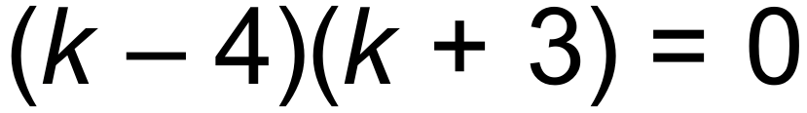
One solution, therefore intersects at only one point. [5]

9. (a) 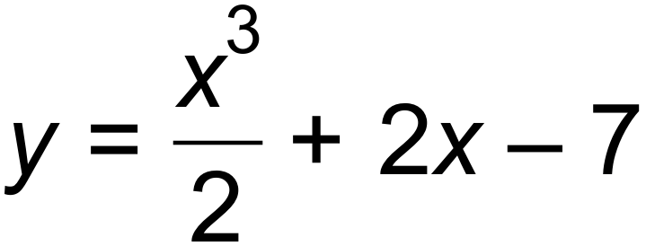
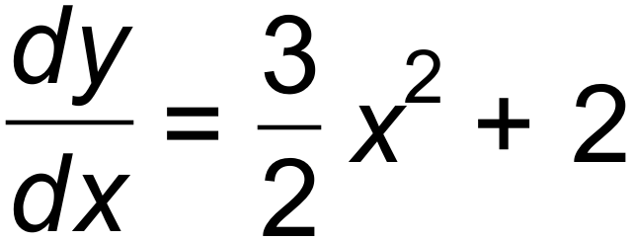
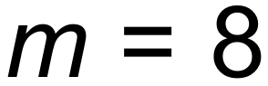
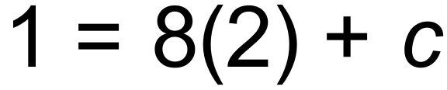
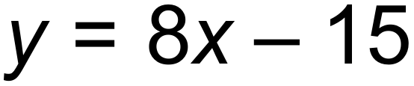
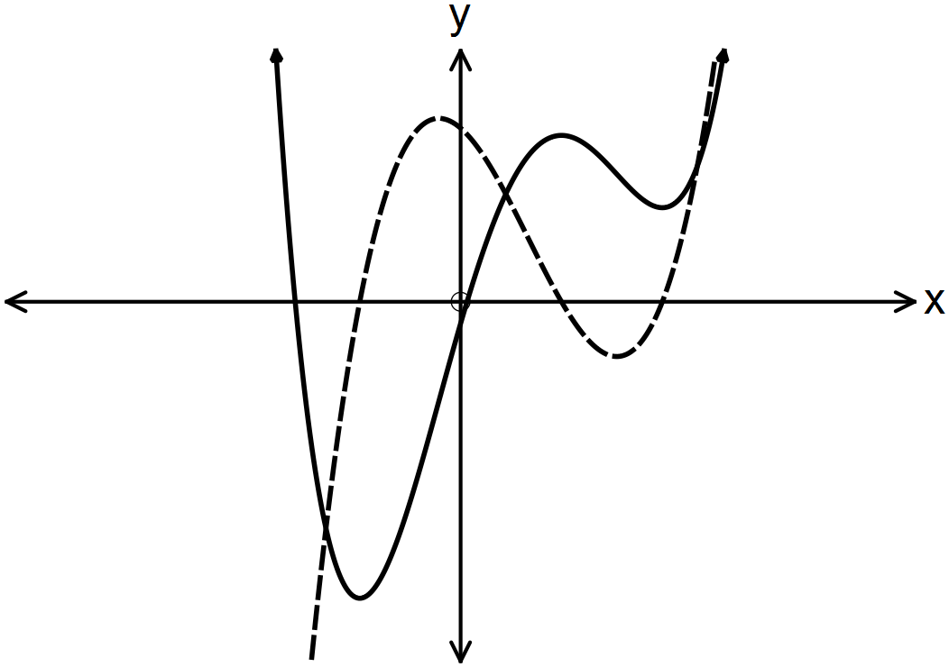 (b)

[6]

10. (a) Period 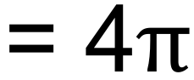
Amplitude = 2
(b)
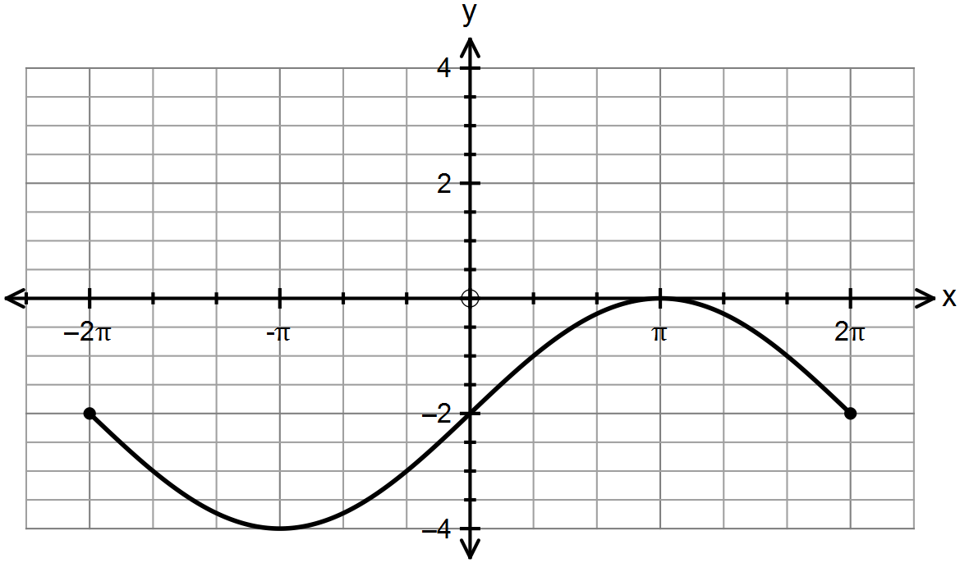

[5]

Calculator−assumed Solutions

11. (a) The number of phones she is given to repair for the week.
(b) She fixes 23 per day, for 4 days 23 x 4 = 92 phones
(c) 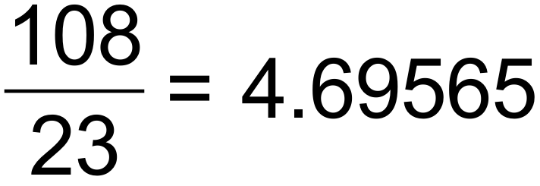 days
hours
5 hours and 34 minutes
(d) T₁ =155 T₂ = 128 T₃ = 99 T₄ =68
T_{n+1} = T_{n} – (25 +2n) T₀ = 180 [6]

12. (a) 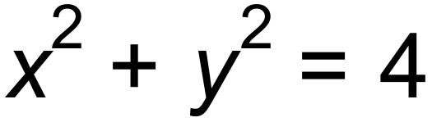
(b) 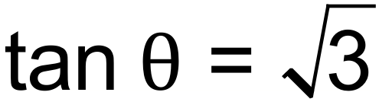 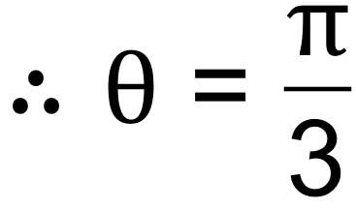 radians
radius = 2 units
(c) 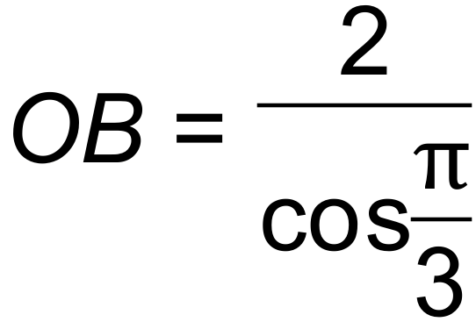 = 4
Therefore area of ΔAOB = 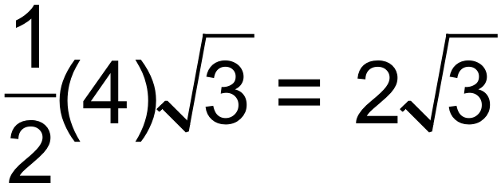 units²
Area of sector = 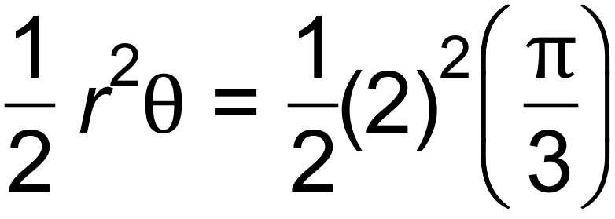
= 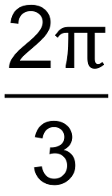 units²
Area of shaded part = triangle – sector
= 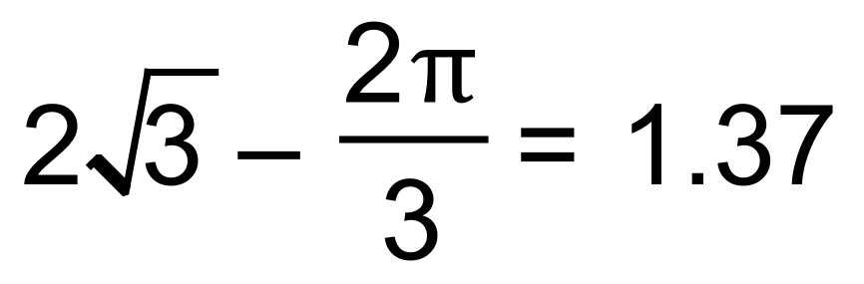units² (3 sig fig) [6]

13. (a) 5.1 seconds
(b) 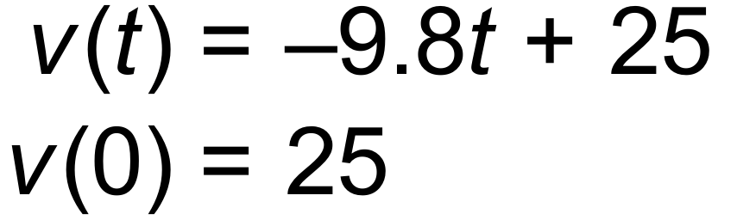
(c) Maximum height is 31.89 m when 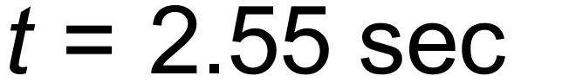
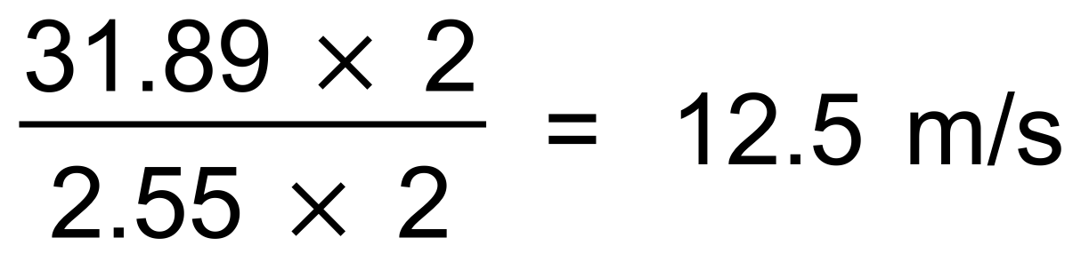 [5]

14. (a) 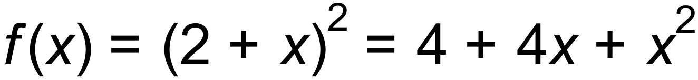
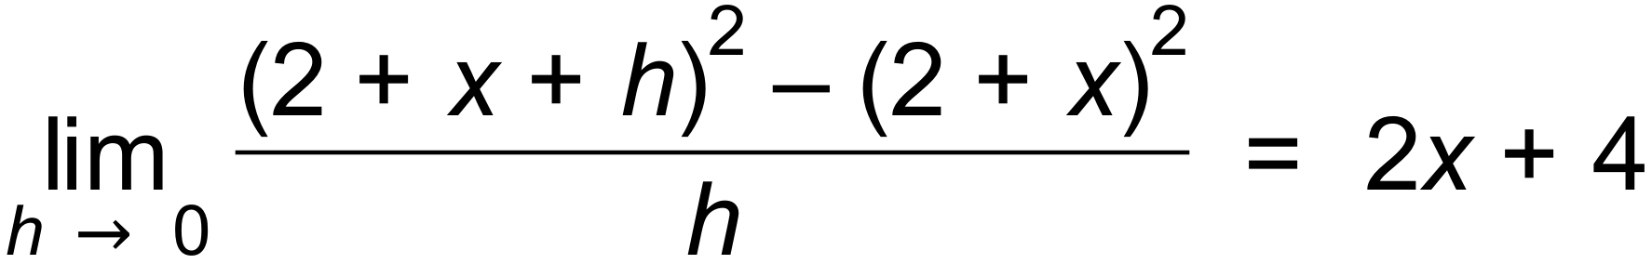
(b) (i) 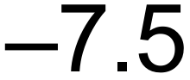
(ii) 18
(c) 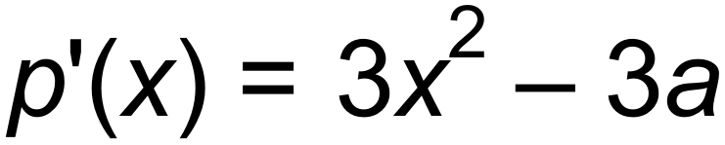
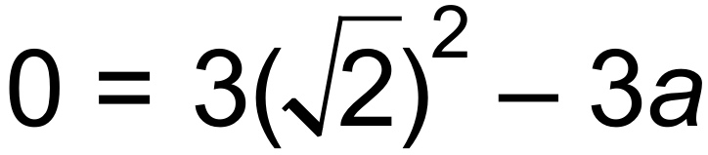
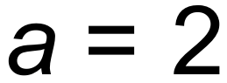
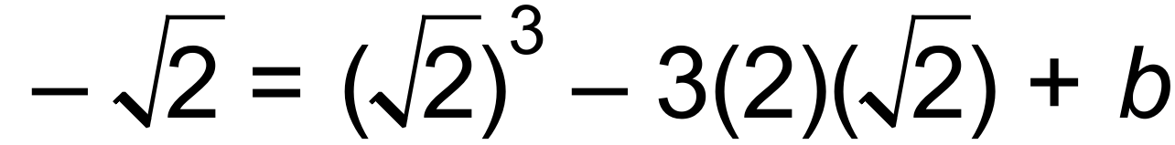
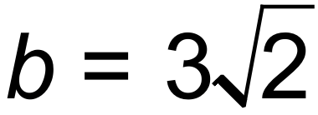 [7]

15. (a) 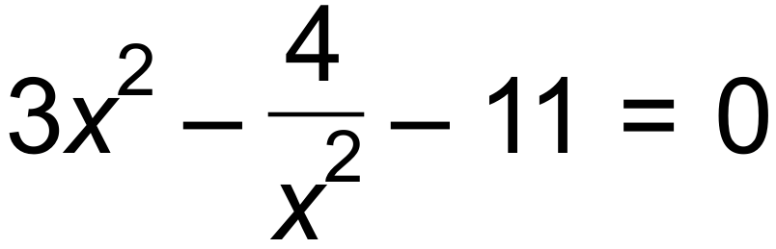


 |  | 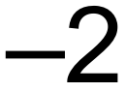 |  | 2
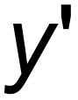 | + | 0 |  | 0 | +
y | ↑ | - | ↓ | - | ↑
(b)

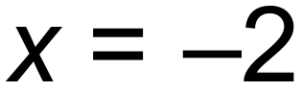 Maximum
 Minimum
(c) 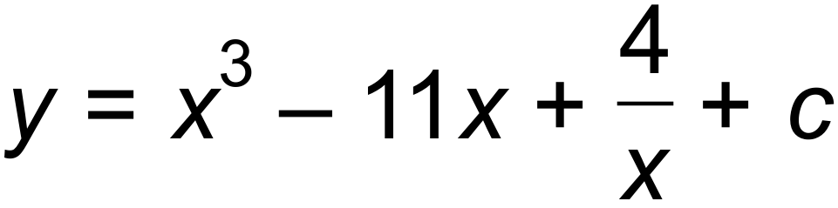
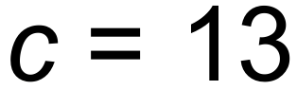
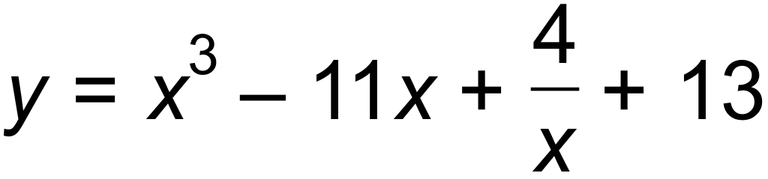
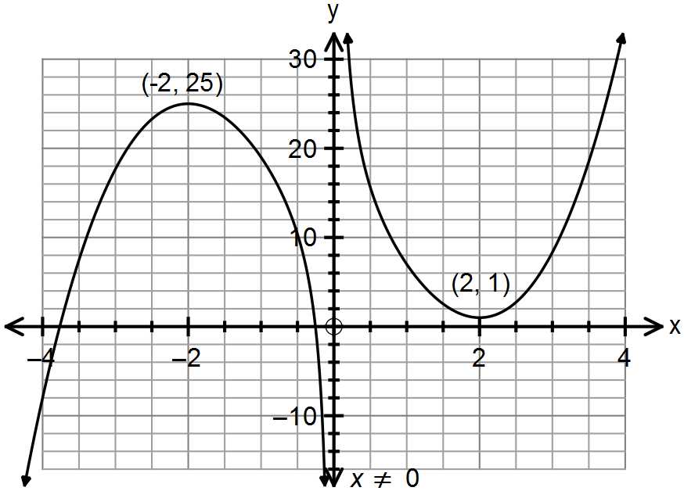(d)

[10]

16. (a) (i) T₁₀₀ = 23 +(99)(9)
= 914
(ii) 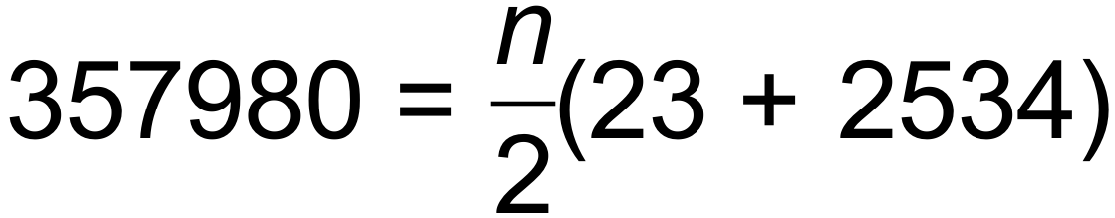
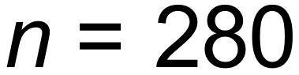
(b) (i) T_{n+1} = T_{n} T₁ = 12
(ii) 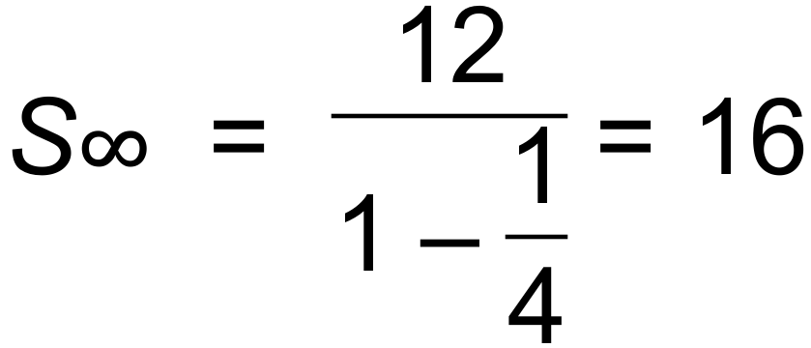 [8]

17. (a) 92°C (initial temp of tea)
22°C (room temp)
(b) After 4.12 mins and before 7.45 mins
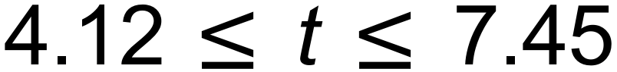
(c) Horizontal asymptote 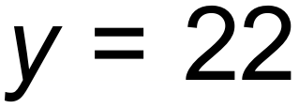
The tea will cool at a decreasing rate as it approaches room
temperature which is 22°. [6]

18. (a) 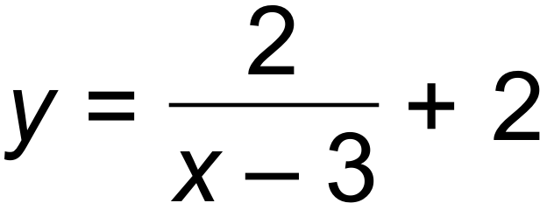
(b) 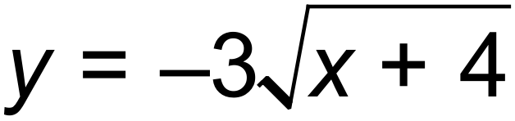
(c) 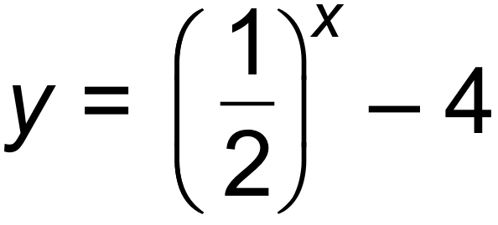 [6]

19. (a) 0.2
(b) 0.5
(c) 0.3
(d) Pr(X  Y) = Pr(X) x Pr(Y) if independent
Pr(X  Y) = Pr(X) + P(Y) - Pr(X  Y)
Pr(X) + Pr(Y) - Pr(X  Y) = Pr(X) x Pr(Y)
Let Pr(Y) = k
0.5+ k - 0.8 = 0.5k
k = 0.6 = Pr (Y) [6]

20. (a) 1, 3, 7, 15,…
T_{n+1} = T_{n} + 2^{n} T₁ = 1
(b) 20 sets [3]

21. (a) (i) 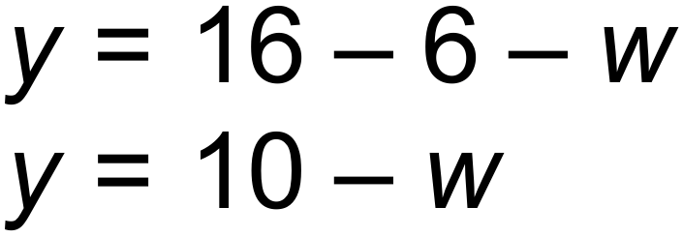
(ii) 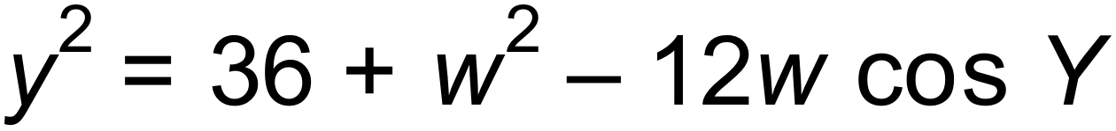
(iii)
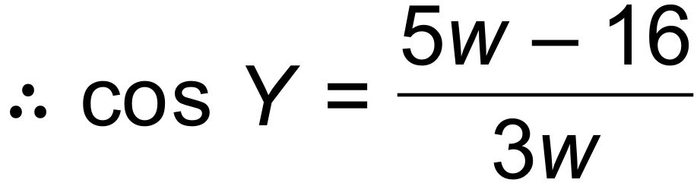
(b) (i) 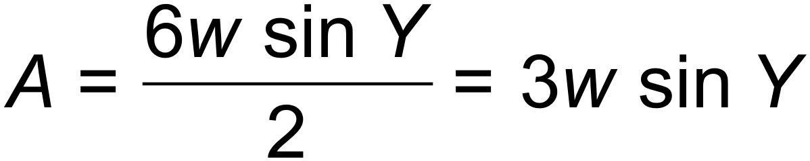
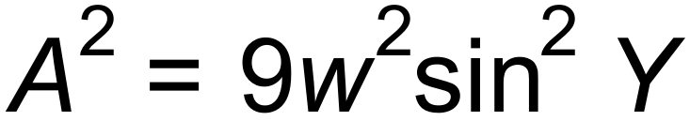
(ii) 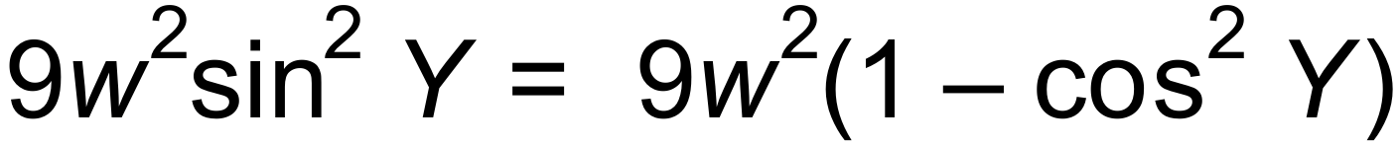
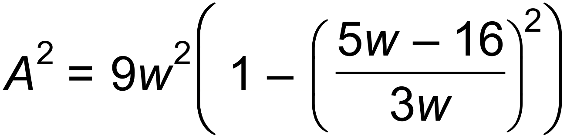
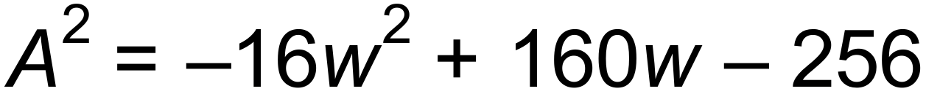
(c) (i) 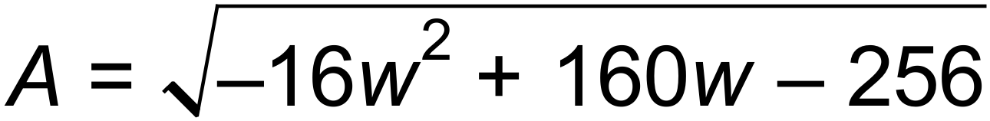

Maximum area = 12 units²
(ii) 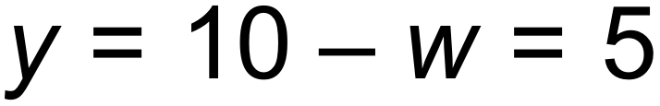
The triangle is isosceles. [12]

22. 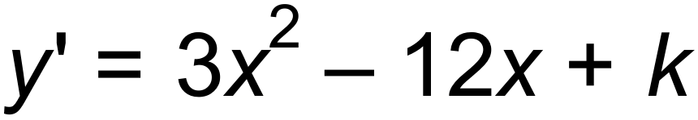
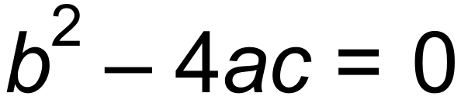 for one solution
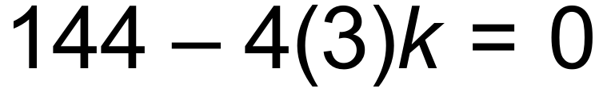
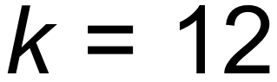 [3]

23. (a) W = W₀ (1.085)^{t}
R = R₀ (0.95)^{t}
10W₀ = R₀
W₀ (1.085)^{t} = 10 x W₀ (0.95)^{t}
(1.085)^{t} = 10(0.95)^{t}
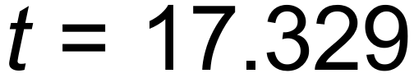 years
After 18 years there will be more wallabies.
(b) W_{n+1} = 1.085 W_{n} W₀ = 655
W₅ = 985 [5]

24. (a) 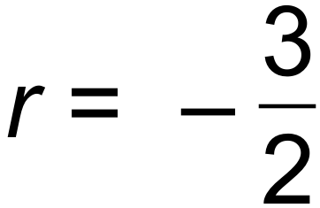
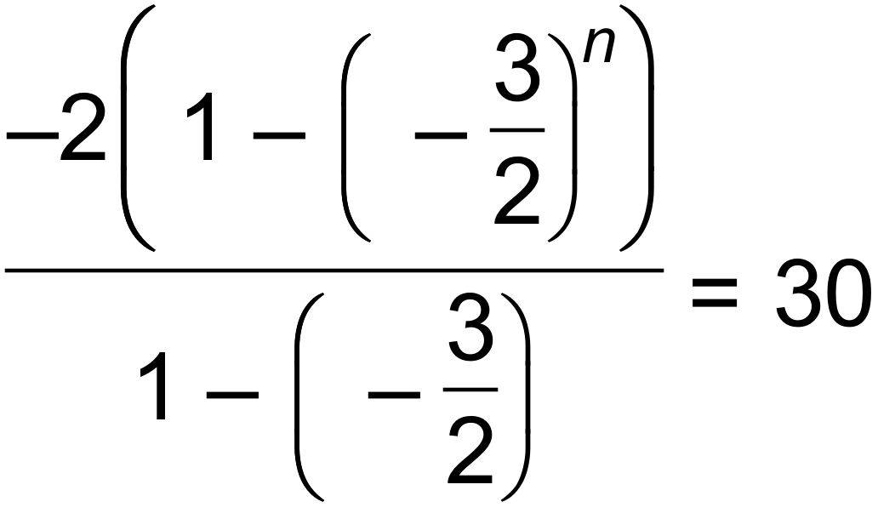
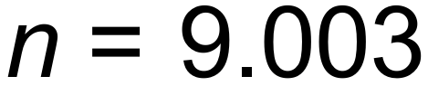

(b) T₅ = 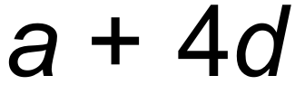 and T₇ = 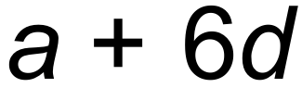
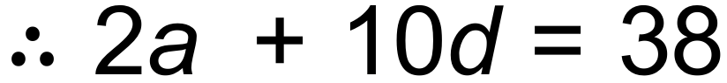 (eq 1)
S₁₅ 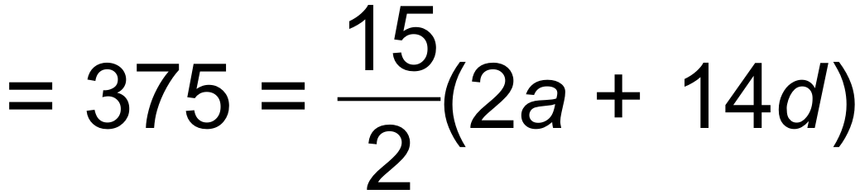 (eq 2)
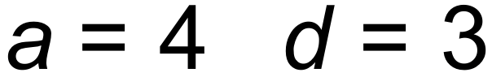
S₃₀ 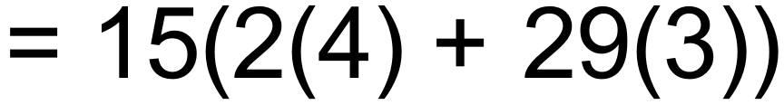 = 1425
Sum of next 15 terms = S₃₀  S₁₅ = 1050 [7]

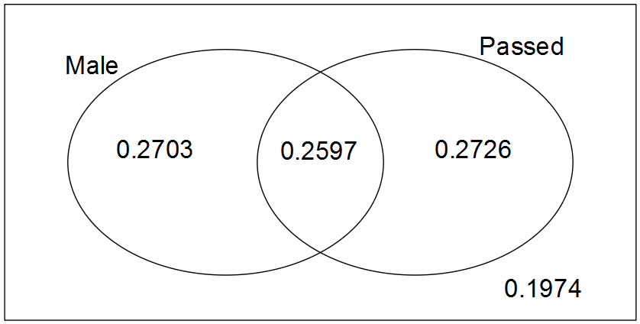25. (a)

(b) (i) 0.5323
(ii) 0.2726
(iii) 0.51
(iv) 0.8026 [7]

26. The particle’s initial displacement is 5 m to the right of the origin.
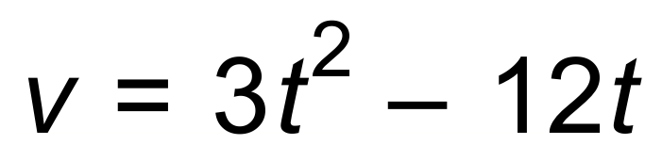 ∴ Initial velocity = 0 [2]

